Learning is fun
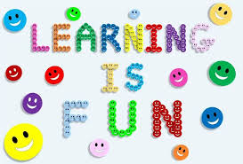

When teachers use activities that make learning engaging and fun, students are more willing to participate and take risks. Having fun while learning also helps students retain information better because the process is enjoyable and memorable.
- Making listening fun
- Making speaking fun
- Making reading fun
- Making writing fun
- Fun Learning is a holistic approach to education with the goal of nurturing the passion for learning and continuous development throughout life.
- Fun Academy developed the 'Fun Learning' approach based on Finnish pedagogical expertise in combination with the best education practices around the world.

